Phase-2
Student Name:T Bharanidharan
Register Number:732123104016
Institution:Nandha College of Technology
Department:B.E. Computer Science And Engineering
Date of Submission:02/05/2025
Github Repository Link:

Problem Statement
In today's digital age, misinformation spreads rapidly across social media and online platforms. Fake news has the potential to mislead users, influence public opinion, and cause real-world harm. This project focuses on detecting fake news articles using Natural Language Processing (NLP) techniques.
- Type of Problem: This is a binary classification problem — the model classifies news as either real or fake.

2.Project Objectives
. • Technical Objectives:
- Clean and preprocess the text data for machine learning.
- Convert text to numerical representations using techniques like TF-IDF or Word Embeddings.
- Train and compare multiple models for classification accuracy and interpretability.
• Model Goal:
- Achieve a balance between high accuracy and generalizability.
- Provide explainable insights about what features contribute to identifying fake news.
• Refined Focus: After data exploration, emphasis was added on understanding feature importance and model interpretability.

3.Flowchart of the Project Workflow

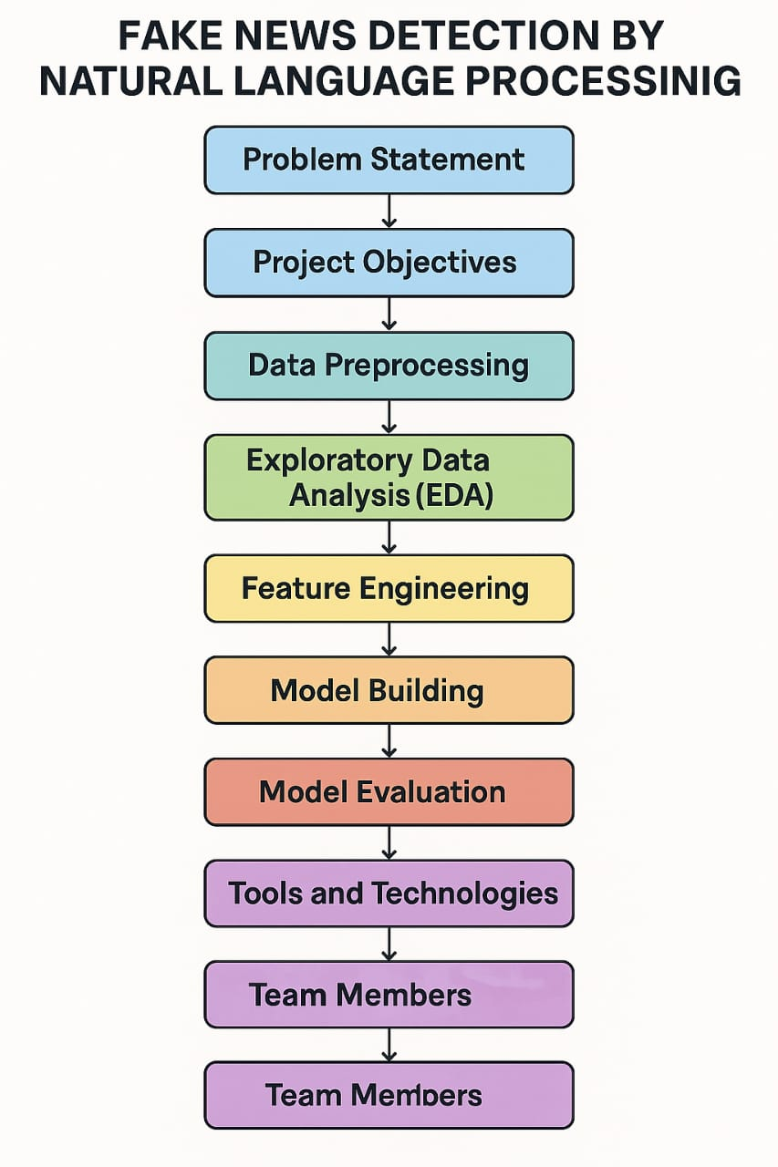

4. Data Description
• Dataset Name: Fake News Detection Dataset
• Source: Kaggle
• Type: Unstructured text data
• Records: ~40,000 news articles
• Features: Title, Text, Subject, Date
• Target Variable: label (0 = fake, 1 = real)
• Nature: Static dataset

5. Data Preprocessing
• Removed null or missing values in the text or title columns.
• Combined title and text for richer context.
• Removed punctuation, stopwords, and applied lemmatization.
• Converted to lowercase and stripped whitespaces.
• Encoded label as binary (0 = fake, 1 = real).
• Vectorized text using TF-IDF.

6. Exploratory Data Analysis (EDA)
Univariate Analysis:
- Word cloud of fake vs. real news.
- Most frequent words in fake vs. real articles.
- Distribution of article lengths.
Bivariate Analysis:
- Correlation between article length and label.
- Word usage frequency comparison.
Insights:
- Fake news often uses emotionally charged language.
- Real news tends to be longer and more fact-based.

7. Feature Engineering
- Added new feature: article length.
- Combined title + text into one feature.
- Used TF-IDF as main feature representation.
- Considered removing rare words and stopwords.
- No dimensionality reduction (to retain explainability).

8. Model Building
- Algorithms Used:
  - Logistic Regression (baseline)
  - Random Forest Classifier (for interpretability and accuracy)
  - [Optionally add Naive Bayes or XGBoost]
- Model Selection Justification:
  - Logistic Regression: simple and effective for binary classification.
  - Random Forest: handles high-dimensional data well.
- Train-Test Split:80%-20%
- Evaluation Metrics:
- Accuracy
- Precision, Recall
- F1-Score
- ROC-AUC

9. Visualization of Results & Model Insights

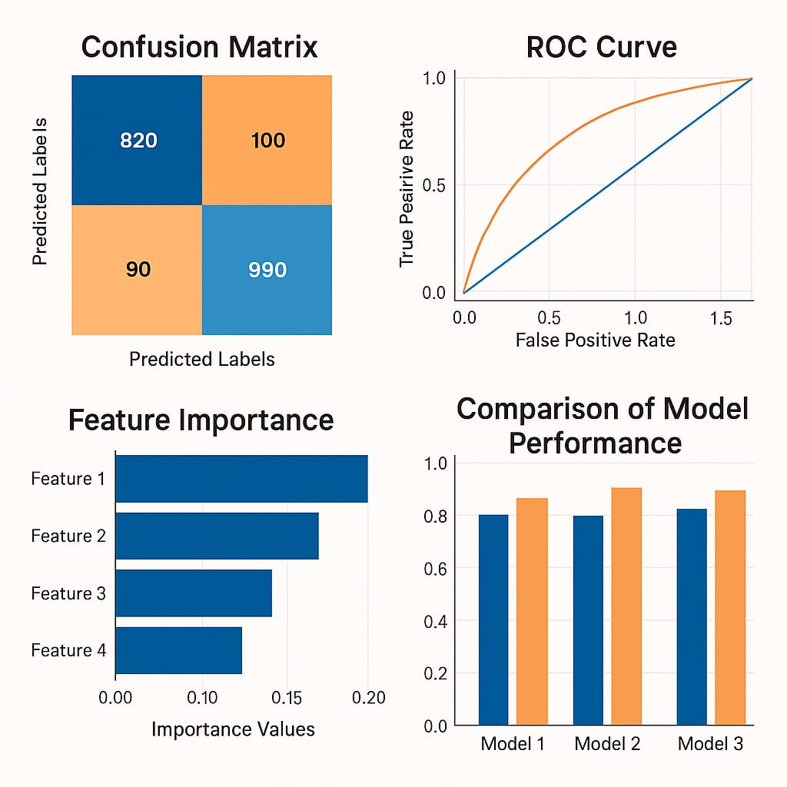

10. Tools and Technologies Used
• Programming Language: Python
• Notebook: Google Colab
• Libraries:
- Data: pandas, numpy
- Visualization: matplotlib, seaborn, wordcloud
- NLP: nltk, sklearn, re
- ML: scikit-learn, xgboost

11. Team Members and Contributions
- R Jayanth: Prepares the dataset and helps with data cleaning.
- M Hari hara sudhan: Explores the data analysis (EDA) and feature engineer.
- T Baranidharan:Prepares the documentation & reporting and model development.

